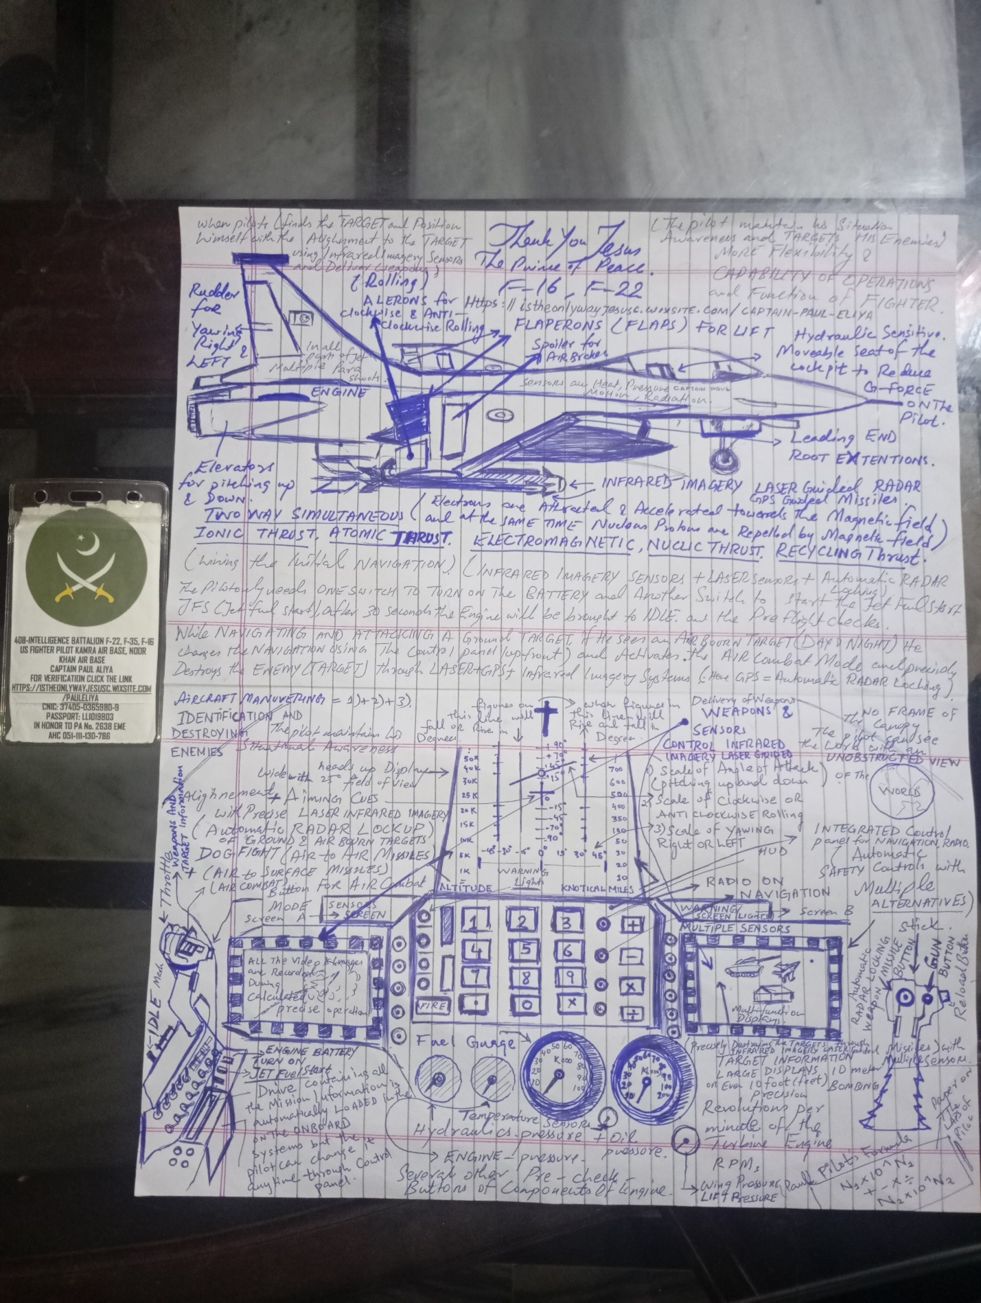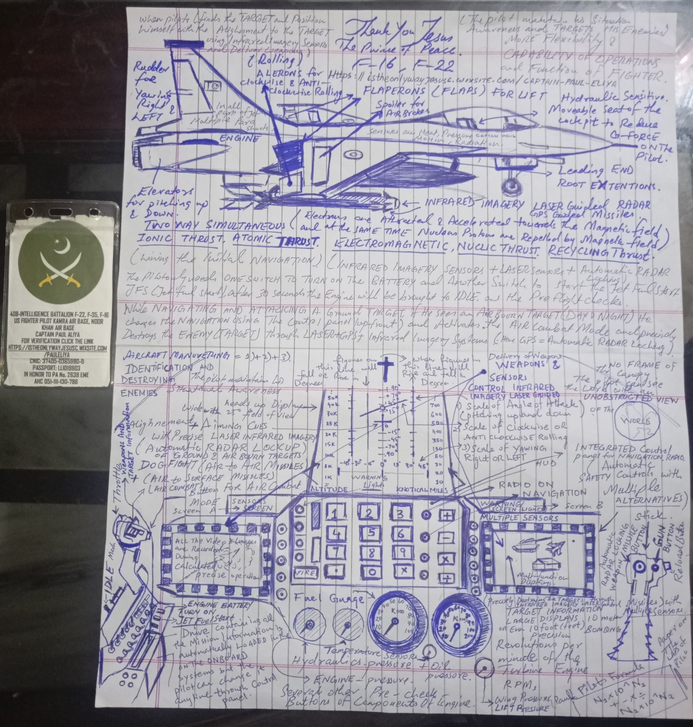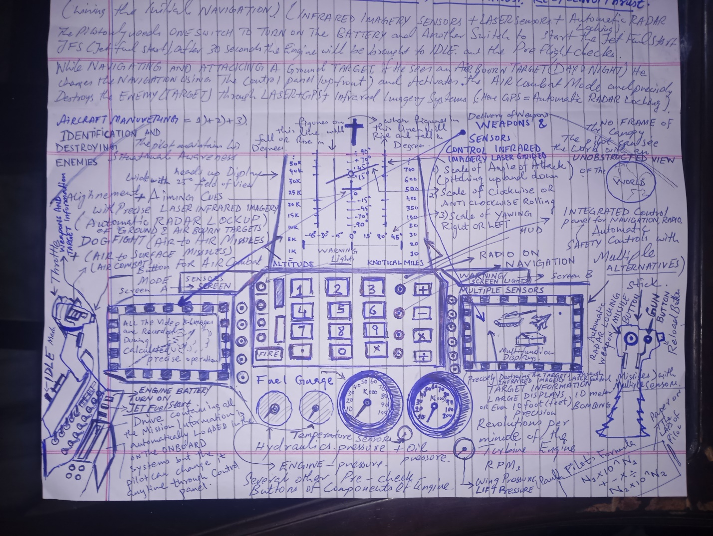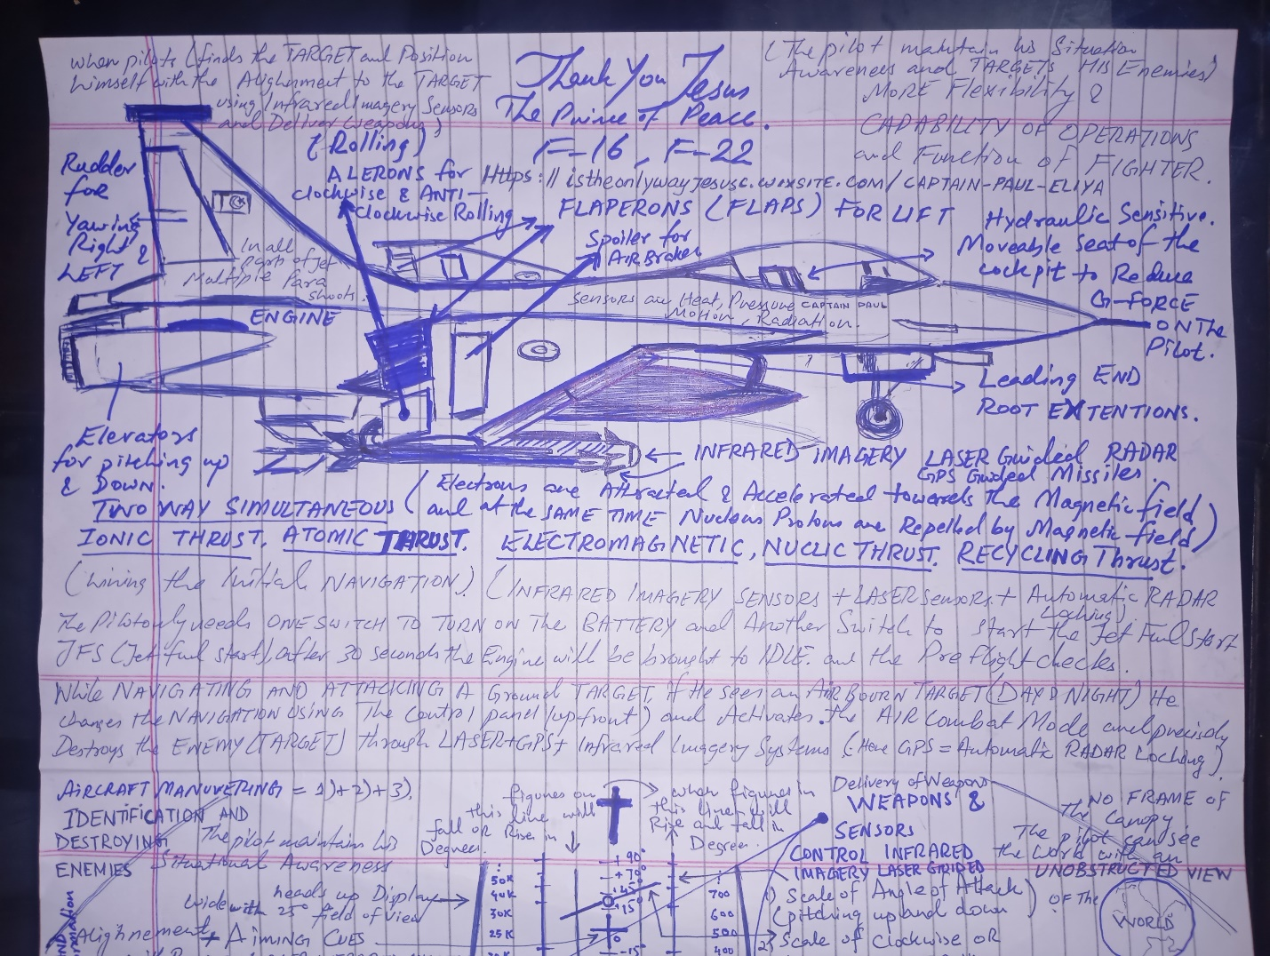
I AM THE UNCONTROLABLE IMAGINATIONS OF PEOPLE AND TIMES DO NOT KEEP COMPANY WITH ME I AM SON OF ALI major changes have been made in the f-16c cockpit these are designed to improve operational capability and flexibility directly in front of me is a new wide-angle heads up display it provides the pilot with all the flight information and weapons aiming cues he needs to keep his head out of the cockpit and on his Target the new HUD also has a rter capability for displaying a 25° field of view of infrared image with an appropriate sensor the pilot can navigate and deliver weapons by using the infrared imagery displayed on the HUD directly below the HUD is the integrated control panel it's placed for easy upfront access to the navigation computer radios and the forward-looking infrared system on both sides of this are two independent multifunction displays they provide weapon and sensor control and large format displays of air to a and air to surface radar information various sensor imagery weapons and stores management data as well as built-in test data prior to flight all of the mission navigation communication and identification data plus Target and weapon information are loaded onto this cassette the pilot then inserts the cassette into the console receptacle and all of the mission information is automatically loaded into the onboard systems of course the pilot can modify that information at any time by using The Upfront control panel as in the f-16a key controls are arranged so that the pilot while on combat can operate with his hands on the stick and throttle for example if while navigating or attacking a ground Target the pilot sees an Airborne threat he can switch to an air combat mode automatically obtain a radar lock destroy that enemy aircraft with an air to- a missile or the gun and then return to the original mode all without moving his hands from the stick or throttle well now let's get in the air it's time to see these systems in operation just like the f-16a the f-16c is easy to start no external support equipment is required we only use one switch to turn on the battery and another switch to start the jet fuel starter 30 seconds later the engine is up to idle speed and the pilot begins his pre-flight checks and lining the inertial navigation set the entire process from start to take off can take less than 1 minute but today we'll take it a little bit easier with the data transfer equipment the entire Mission can be loaded into the aircraft systems in only 5 Seconds Carell tower dm5 for takeoff d9m 5 Carell Tower wind 170 10 C for takeoff D five Roger the excellent field of view from the F-16 cockpit is one of the first things a new pilot notices with no canopy bow frame and a low canopy rail he has an unobstructed view of the world like a flight of two angels 10 Close outs Miss step away in combat of course it wouldn't be this it would be at night L developed by Martin Marietta Corporation stands for low altitude navigation and targeting infrared systems for night it combines forward-looking infrared Imaging terrain following radar Precision pointing and tracking laser designation and ranging and automatic weapons handoffs to minimize pilot workload Pilots of the fourth tactical fighter ring say they can drop their bombs within 10 m some say 10 ft of a Target this accuracy can be achieved using the radar and infrared navigation pod as the pilot goes into an attack he maintains his overall situation awareness in the hood he finds the target area and positions himself with the infrared or Fleer sensor of the navigation P the Final Approach is then set up with the targeting P after Target lockoff the attack is flown heads up with all weapons delivery calculations and functions performed automatically but for all its capabilities istheonlywayjesusc.wixsite.com/captain-paul-eliya

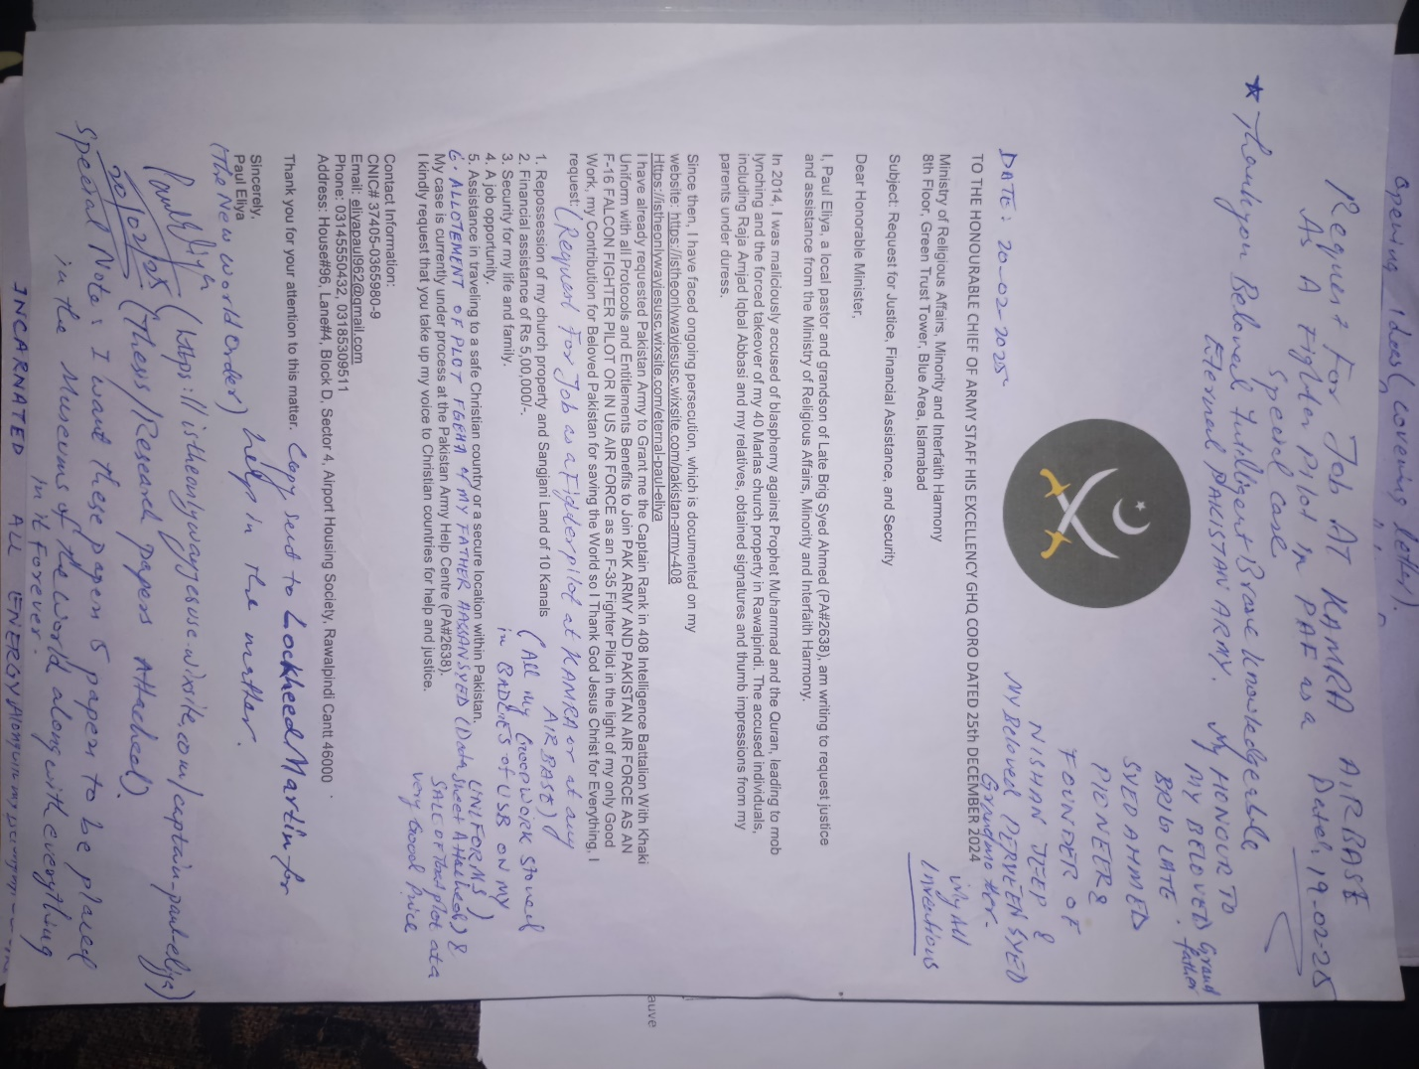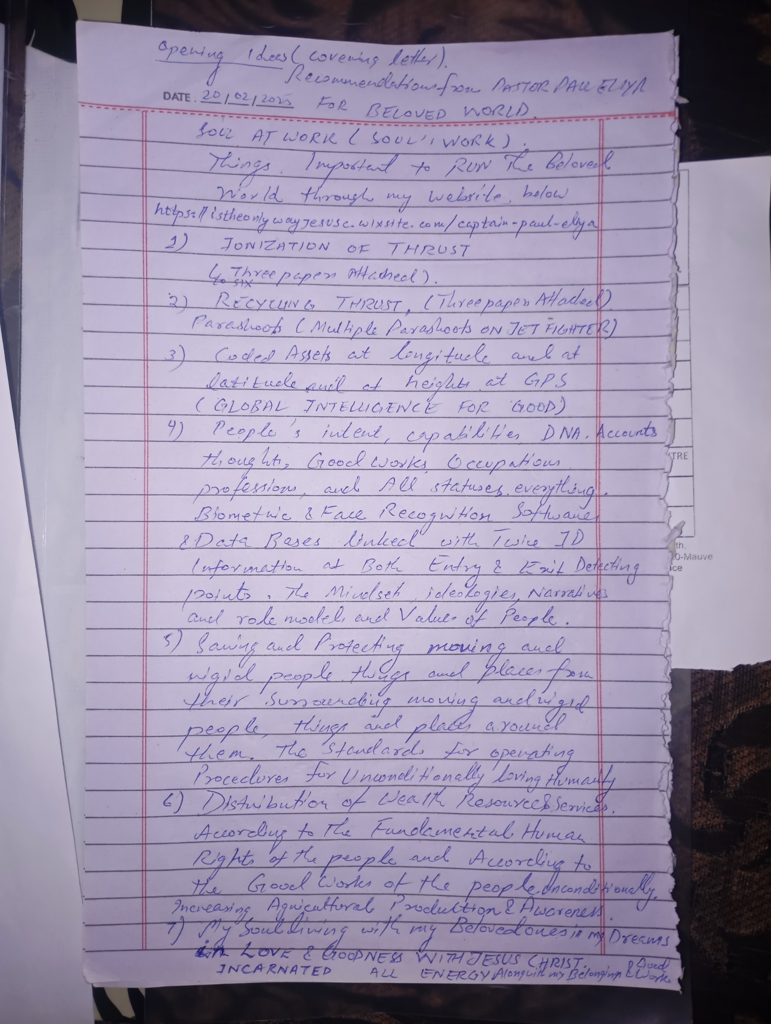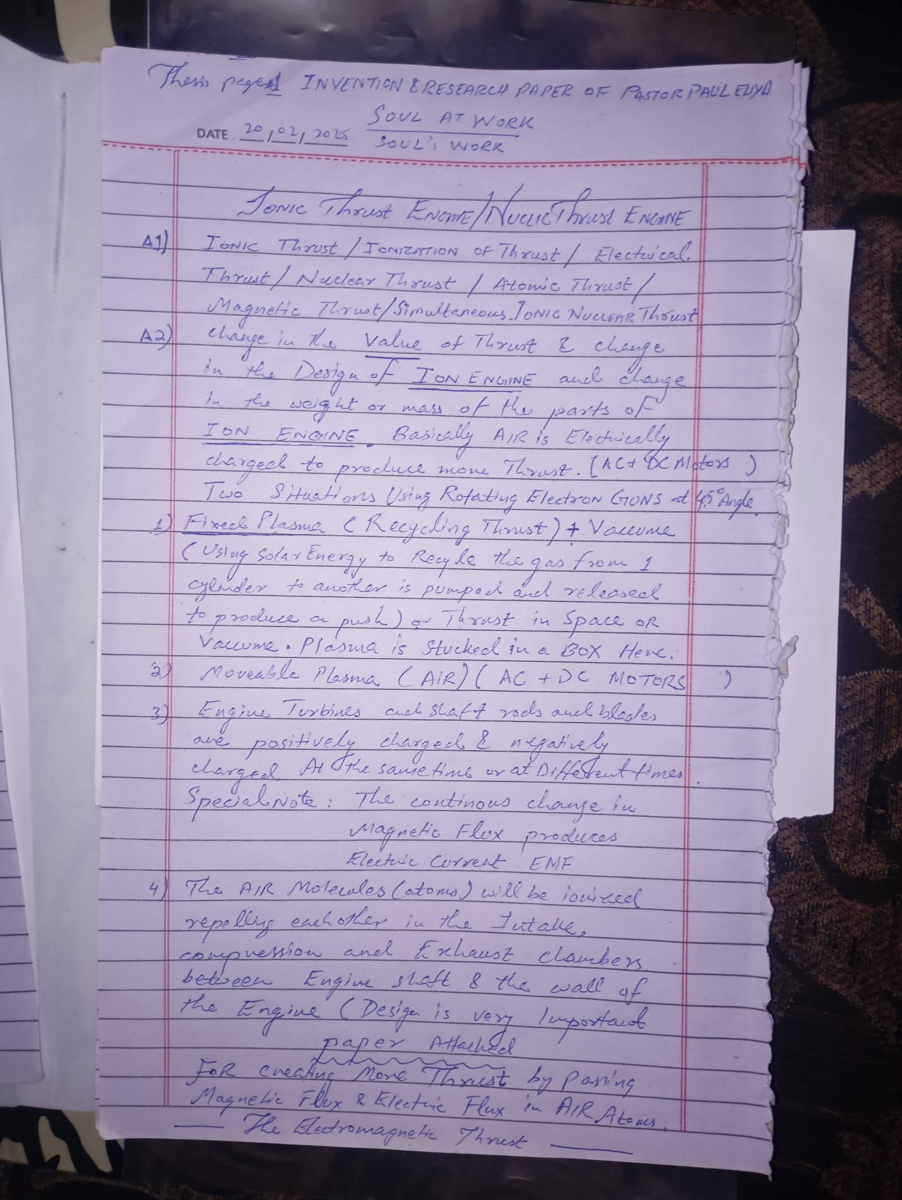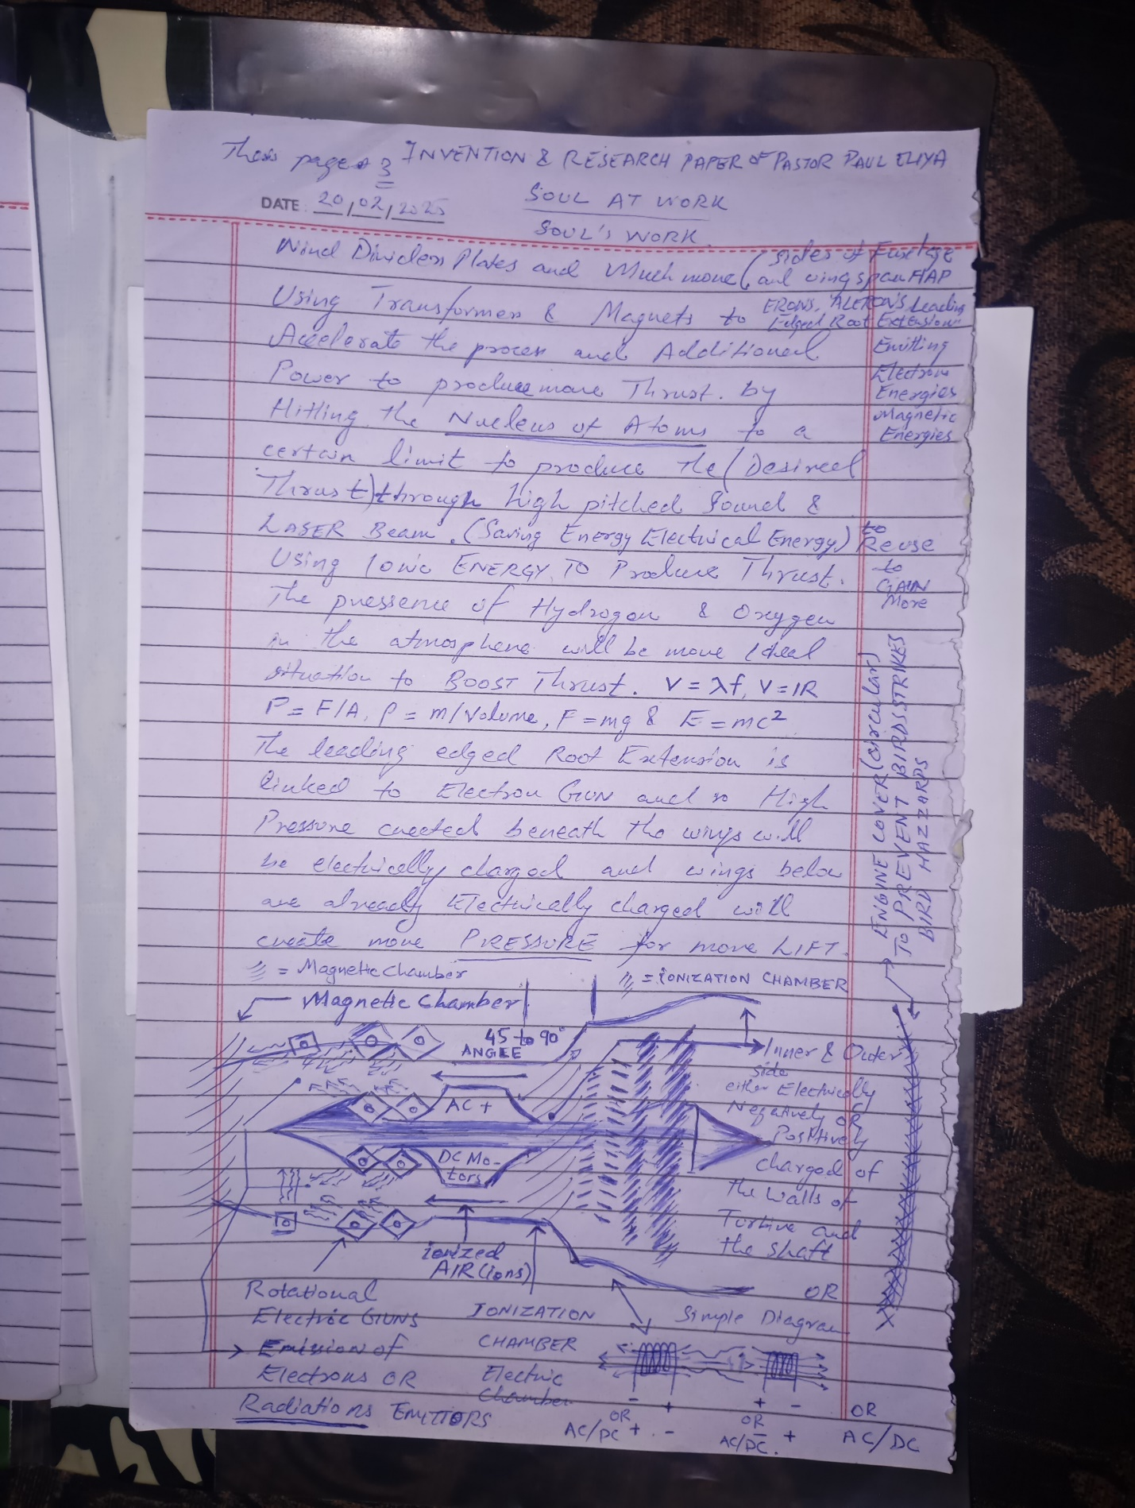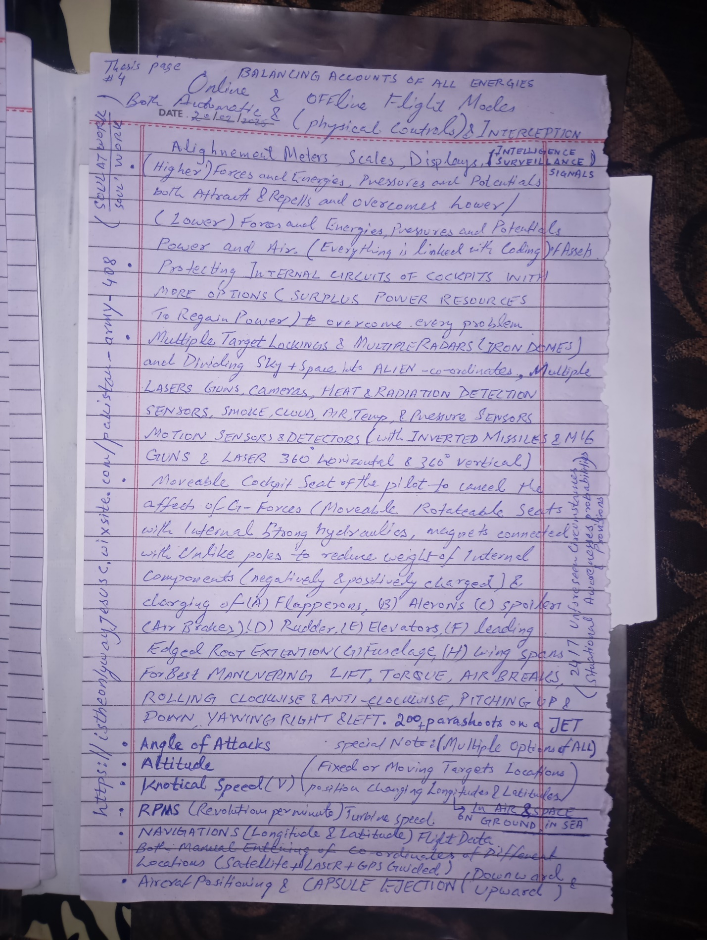

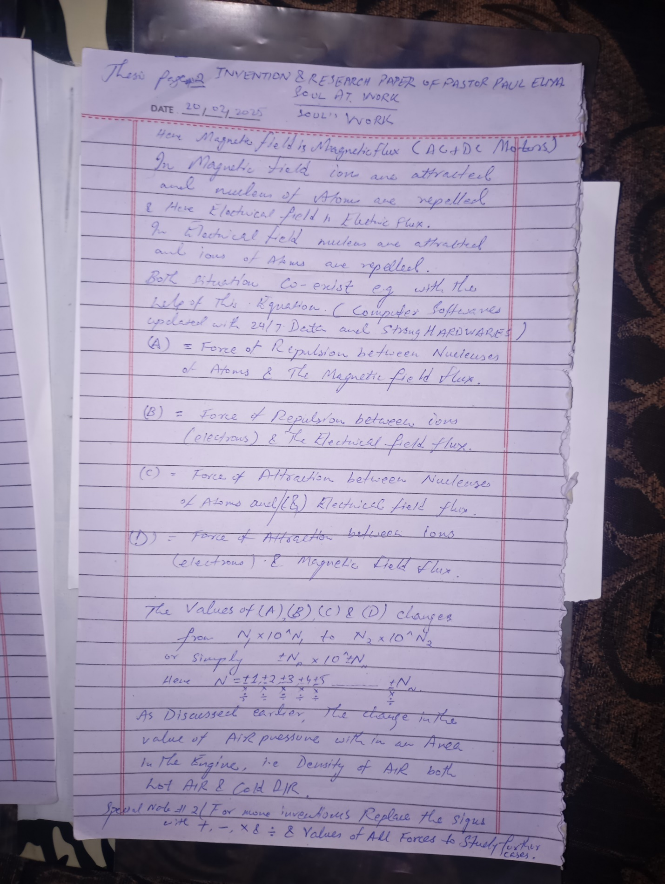

https://istheonlywayjesusc.wixsite.com/indian
https://istheonlywayjesusc.wixsite.com/india
https://istheonlywayjesusc.wixsite.com/christian
https://istheonlywayjesusc.wixsite.com/open-air-church
https://istheonlywayjesusc.wixsite.com/pauleliya
https://istheonlywayjesusc.wixsite.com/captain-paul-eliya
https://istheonlywayjesusc.wixsite.com/top-gun
https://istheonlywayjesusc.wixsite.com/topgun
https://istheonlywayjesusc.wixsite.com/love
https://istheonlywayjesusc.wixsite.com/hero
WHEN THE PLANE IS AT THE SUPERSONIC THE CLOUD THAT IS FORMED AT THE BACK SIDE OF THE JET FIGHTER IS DUE TO SUDDEN DROP IN TEMPERATURE AFTER BEING HEATED IN THE FRONT DUE TO COMPRESSING AIR HIGH PRESSURE AND THEN SUDDEN LOW PRESSURE AND DROP IN TEMPERATURE

