THANK YOU JESUS CHRIST
Inbox

 |  | 15:43 (2 minutes ago)
  Syed Ali Abbas Paul Eliya <eliyasyedaliabbaspaul@gmail.com>
to info, dacf, aileen.zhou, dg, complaint, director.admin, director.finance, director.estate, director.jv, director.law, director.coord, director.IT, director.technical, director.security, director.ia, director.planning, director.land, director.maintenance, director.revenue, director.jvkci, AD.AstonAndSuttonColdfield, AD.ColeshillAndPolesworth, AD.HandsworthAndCentral, AD.KNMS, Admin, Citizen, CPIinfoMali, Courrier, Fadi.El-Abdallah, Falak, FreeJobs, GENESIS, Info, JU, Mike.Sermon, Nick.Parker, OTP, OTPNewsDesk, Ohchr-dexrel, Ombudsman, Passport.london, Paul, Perfect, Procurement, Security, Here's, Sohaibchoudry221998, me, WaleedbinToufeeq, WeTrip, achats, administrator, agnes.eklund, agnes.jansson, ahmadiaportugal, alexandra.cederquist, amjmalta, andia.gemsjo, anna.erhardt, anna.lund, apdpftac2, applications, appt.london, atfal, attcons.washington, bilal.lodhi, bishop.david, bishopofaston, bishopsadmin, bookkeeping, caritas.internationalis, cee-office, ceo, com.tehran, com3.washington, commregen, comms, communications, cons.islamabad, cons.tehran, cons1.telaviv, cons2.telaviv, cons6.washington, consuly, contact, contact, contact, contactus, contatti, copyright, dave, dioceseoflondon, discipleship, donorcare, eastafritac, editor, education, elana, emergencies, enquiry, environment, farrakhmansoor, financeteam, flex, frezza, fsoci.washington, fspic.washington, fund, givingtogether, glavno.tajnistvo, hammad.tariq, helpdesk, helpdesk, helplinephc, hoc.babbas, hoc.tehran, hqepu, hr, hr, hrmartha, i.registrar, ieo, imam.ahmed, imffa, imfvideo, inclusiveandaccessible, info, info, info, info, info, info, info, info, info, info, info, info, info, info, info, info, info, info, information, information.hebrew, interculturalmission, interfaith, irnte, irnteprt, isaac.elm.communications, isbad, jennyt, ju.registrar, kancelaria, khuddamireland, kontakt, kontakt, kontakt, kpk, lahore, lahore_churchcouncil, library, marriagebureau34, media, media, mineco.washington, ministry, mohsin.talpur, mubbbutt, muhammad.tariq, newchristiancommunities, ngoliaison, niazihaider786, obedarthur, office, office, ohchr-unvfvt, opinia_ta, ouse, paivytys.um, panatz, parishmissionsupport, parishsurveyor, pathways, peopleandplaces, petrosillo, pniot, press, pressoffice, procurement, property, psamb.washington, psdcm.washington, publicaffairs, publications, reception, recrutement-recruitment, reehanashraf, refworld, revchris007, safeguardingsupport, sah, sanam.javed, sbs.malta.heliga-stolen, secministerialmeetings, secretariat, sektor.jd.ks, shahid.wazir, socialdepartementet.registrator, spain, spyropoulos, support, support-india, support-pakistan, tcpak, ujieuropa, ured.drzavnog.tajnika, v-bknoojh_nnpgdkmghf_jdofaikg_jdoelhap_a, visa.islamabad, visaservicesphcnd, vocations, web, webmaster, weddings, contact, Пакистан, islamabad, islamabad.hum, islamabad.visa, islamabad.ziv, islamabad, pakistan, Webmaster, asrcrwp, asrcfsd, asrclhr, asrckci, asrcpsc, asrcqta, asrcglt, asrcmzd, asrcmtn, asrckzd, asrchyd, asrcdik, asrcpnl, complaint, Public, Paul, dd-it1, press, icc, press, bcc: info, bcc: dacf, bcc: aileen.zhou, bcc: dg, bcc: complaint, bcc: director.admin, bcc: director.finance, bcc: director.estate, bcc: director.jv, bcc: director.law, bcc: director.coord, bcc: director.IT, bcc: director.technical, bcc: director.security, bcc: director.ia, bcc: director.planning, bcc: director.land, bcc: director.maintenance, bcc: director.revenue, bcc: director.jvkci, bcc: AD.AstonAndSuttonColdfield, bcc: AD.ColeshillAndPolesworth, bcc: AD.HandsworthAndCentral, bcc: AD.KNMS, bcc: Admin, bcc: Citizen, bcc: CPIinfoMali, bcc: Courrier, bcc: Fadi.El-Abdallah, bcc: Falak, bcc: FreeJobs, bcc: GENESIS, bcc: Info, bcc: JU, bcc: Mike.Sermon, bcc: Nick.Parker, bcc: OTP, bcc: OTPNewsDesk, bcc: Ohchr-dexrel, bcc: Ombudsman, bcc: Passport.london, bcc: Paul, bcc: Perfect, bcc: Procurement, bcc: Security, bcc: Here's, bcc: Sohaibchoudry221998, bcc: me, bcc: WaleedbinToufeeq, bcc: WeTrip, bcc: achats, bcc: administrator, bcc: agnes.eklund, bcc: agnes.jansson, bcc: ahmadiaportugal, bcc: alexandra.cederquist, bcc: amjmalta, bcc: andia.gemsjo, bcc: anna.erhardt, bcc: anna.lund, bcc: apdpftac2, bcc: applications, bcc: appt.london, bcc: atfal, bcc: attcons.washington, bcc: bilal.lodhi, bcc: bishop.david, bcc: bishopofaston, bcc: bishopsadmin, bcc: bookkeeping, bcc: caritas.internationalis, bcc: cee-office, bcc: ceo, bcc: com.tehran, bcc: com3.washington, bcc: commregen, bcc: comms, bcc: communications, bcc: cons.islamabad, bcc: cons.tehran, bcc: cons1.telaviv, bcc: cons2.telaviv, bcc: cons6.washington, bcc: consuly, bcc: contact, bcc: contact, bcc: contact, bcc: contactus, bcc: contatti, bcc: copyright, bcc: dave, bcc: dioceseoflondon, bcc: discipleship, bcc: donorcare, bcc: eastafritac, bcc: editor, bcc: education, bcc: elana, bcc: emergencies, bcc: enquiry, bcc: environment, bcc: farrakhmansoor, bcc: financeteam, bcc: flex, bcc: frezza, bcc: fsoci.washington, bcc: fspic.washington, bcc: fund, bcc: givingtogether, bcc: glavno.tajnistvo, bcc: hammad.tariq, bcc: helpdesk, bcc: helpdesk, bcc: helplinephc, bcc: hoc.babbas, bcc: hoc.tehran, bcc: hqepu, bcc: hr, bcc: hr, bcc: hrmartha, bcc: i.registrar, bcc: ieo, bcc: imam.ahmed, bcc: imffa, bcc: imfvideo, bcc: inclusiveandaccessible, bcc: info, bcc: info, bcc: info, bcc: info, bcc: info, bcc: info, bcc: info, bcc: info, bcc: info, bcc: info, bcc: info, bcc: info, bcc: info, bcc: info, bcc: info, bcc: info, bcc: info, bcc: info, bcc: information, bcc: information.hebrew, bcc: interculturalmission, bcc: interfaith, bcc: irnte, bcc: irnteprt, bcc: isaac.elm.communications, bcc: isbad, bcc: jennyt, bcc: ju.registrar, bcc: kancelaria, bcc: khuddamireland, bcc: kontakt, bcc: kontakt, bcc: kontakt, bcc: kpk, bcc: lahore, bcc: lahore_churchcouncil, bcc: library, bcc: marriagebureau34, bcc: media, bcc: media, bcc: mineco.washington, bcc: ministry, bcc: mohsin.talpur, bcc: mubbbutt, bcc: muhammad.tariq, bcc: newchristiancommunities, bcc: ngoliaison, bcc: niazihaider786, bcc: obedarthur, bcc: office, bcc: office, bcc: ohchr-unvfvt, bcc: opinia_ta, bcc: ouse, bcc: paivytys.um, bcc: panatz, bcc: parishmissionsupport, bcc: parishsurveyor, bcc: pathways, bcc: peopleandplaces, bcc: petrosillo, bcc: pniot, bcc: press, bcc: pressoffice, bcc: procurement, bcc: property, bcc: psamb.washington, bcc: psdcm.washington, bcc: publicaffairs, bcc: publications, bcc: reception, bcc: recrutement-recruitment, bcc: reehanashraf, bcc: refworld, bcc: revchris007, bcc: safeguardingsupport, bcc: sah, bcc: sanam.javed, bcc: sbs.malta.heliga-stolen, bcc: secministerialmeetings, bcc: secretariat, bcc: sektor.jd.ks, bcc: shahid.wazir, bcc: socialdepartementet.registrator, bcc: spain, bcc: spyropoulos, bcc: support, bcc: support-india, bcc: support-pakistan, bcc: tcpak, bcc: ujieuropa, bcc: ured.drzavnog.tajnika, bcc: v-bknoojh_nnpgdkmghf_jdofaikg_jdoelhap_a, bcc: visa.islamabad, bcc: visaservicesphcnd, bcc: vocations, bcc: web, bcc: webmaster, bcc: weddings, bcc: contact, bcc: Пакистан, bcc: islamabad, bcc: islamabad.hum, bcc: islamabad.visa, bcc: islamabad.ziv, bcc: islamabad, bcc: pakistan, bcc: Webmaster, bcc: asrcrwp, bcc: asrcfsd, bcc: asrclhr, bcc: asrckci, bcc: asrcpsc, bcc: asrcqta, bcc: asrcglt, bcc: asrcmzd, bcc: asrcmtn, bcc: asrckzd, bcc: asrchyd, bcc: asrcdik, bcc: asrcpnl, bcc: complaint, bcc: Public, bcc: Paul, bcc: dd-it1, bcc: press, bcc: icc, bcc: press

from: | Syed Ali Abbas Paul Eliya <eliyasyedaliabbaspaul@gmail.com>
to: | info <info@domotexasiachinafloor.com>,  dacf@press.globusevents.com,  aileen.zhou@globusevents.com,  dg@fgeha.gov.pk,  complaint@fgeha.gov.pk,  director.admin@fgeha.gov.pk,  director.finance@fgeha.gov.pk,  director.estate@fgeha.gov.pk,  director.jv@fgeha.gov.pk,  director.law@fgeha.gov.pk,  director.coord@fgeha.gov.pk,  director.IT@fgeha.gov.pk,  director.technical@fgeha.gov.pk,  director.security@fgeha.gov.pk,  director.ia@fgeha.gov.pk,  director.planning@fgeha.gov.pk,  director.land@fgeha.gov.pk,  director.maintenance@fgeha.gov.pk,  director.revenue@fgeha.gov.pk,  director.jvkci@fgeha.gov.pk,  AD.AstonAndSuttonColdfield@cofebirmingham.com,  AD.ColeshillAndPolesworth@cofebirmingham.com,  AD.HandsworthAndCentral@cofebirmingham.com,  AD.KNMS@cofebirmingham.com,  Admin@azadchaiwala.com,  Citizen Service of the Ministry of Foreign Affairs <borgarathjonusta@utn.is>,  CPIinfoMali@icc-cpi.int,  Courrier Elysée <courrier.president@elysee.fr>,  Fadi.El-Abdallah@icc-cpi.int,  Falak Tayab Corporate Service <careers@falaktayabcorporateservices.com>,  FreeJobs UAE <pr@advancelevelcon.com>,  GENESIS@matrimony.com,  Info@iranembassy.pk,  JU Brev <ju.brev@regeringskansliet.se>,  Mike.Sermon@cofebirmingham.com,  Nick.Parker@cofebirmingham.com,  "OTP InformationDesk (Article15)" <otp.informationdesk@icc-cpi.int>,  OTPNewsDesk@icc-cpi.int,  Ohchr-dexrel@un.org,  Ombudsman@mevaker.gov.il,  Passport.london@mea.gov.in,  Paul Eliya <eliyapaul289@gmail.com>,  Perfect LLC <hr@perfectllcdubai.com>,  Procurement@icc-cpi.int,  Security@icc-cpi.int,  Here's Puthran <visa.washington@mea.gov.in>,  Sohaibchoudry221998@gmail.com,  Syed Ali Abbas Paul Eliya <eliyasyedaliabbaspaul@gmail.com>,  WaleedbinToufeeq@gmail.com,  WeTrip <contact@wetrip.pk>,  achats@icj-cij.org,  administrator@stmarksitaly.com,  agnes.eklund@regeringskansliet.se,  agnes.jansson@gov.se,  ahmadiaportugal@hotmail.com,  alexandra.cederquist@gov.se,  amjmalta@gmail.com,  andia.gemsjo@regeringskansliet.se,  anna.erhardt@gov.se,  anna.lund@gov.se,  apdpftac2@imf.org,  applications@icc-cpi.int,  appt.london@mea.gov.in,  atfal@atfal.de,  attcons.washington@mea.gov.in,  bilal.lodhi@bop.com.pk,  bishop.david@manchester.anglican.org,  bishopofaston@cofebirmingham.com,  bishopsadmin@cofebirmingham.com,  bookkeeping@cofebirmingham.com,  caritas.internationalis@caritas.va,  cee-office@imf.org,  ceo@sadiqtravels.com,  com.tehran@mea.gov.in,  com3.washington@mea.gov.in,  commregen@cofebirmingham.com,  comms@cofebirmingham.com,  communications@london.anglican.org,  cons.islamabad@mea.gov.in,  cons.tehran@mea.gov.in,  cons1.telaviv@mea.gov.in,  cons2.telaviv@mea.gov.in,  cons6.washington@mea.gov.in,  consuly@iranembassy.pk,  contact@fatf-gafi.org,  contact@ahmadiyya.fr,  contact@ahmadiyya.dk,  contactus@iaa.gov.il,  contatti@alislam.it,  copyright@imf.org,  dave@redeemerdubai.com,  dioceseoflondon@luther.co.uk,  discipleship@cofebirmingham.com,  donorcare@unhcr.ca,  eastafritac@imf.org,  editor@chanakyaforum.com,  education@cofebirmingham.com,  elana@israelforever.org,  emergencies@caritas.va,  enquiry@churchofengland.org,  environment@cofebirmingham.com,  farrakhmansoor@hot.ee,  financeteam@cofebirmingham.com,  flex@cofebirmingham.com,  frezza@caritas.va,  fsoci.washington@mea.gov.in,  fspic.washington@mea.gov.in,  fund@end-violence.org,  givingtogether@imf.org,  glavno.tajnistvo@mvep.hr,  hammad.tariq@sindhbankltd.com,  helpdesk@lajnauk.org,  helpdesk@lajna.be,  helplinephc@gmail.com,  hoc.babbas@mea.gov.in,  hoc.tehran@mea.gov.in,  hqepu@unhcr.org,  hr@cofebirmingham.com,  hr fatima ali <hrfatimaali@gmail.com>,  hrmartha roy <hrmagraroy@gmail.com>,  i.registrar@gov.se,  ieo@imf.org,  imam.ahmed@ahmadiyya.ch,  imffa@imf.org,  imfvideo@imf.org,  inclusiveandaccessible@cofebirmingham.com,  info@thrivetogetherbham.org,  info@ahmadiyya.ch,  info@education.gov.il,  info@imfmetac.org,  info@end-violence.org,  info@visitouriran.com,  info@khuddam.co.uk,  info@ziyarahtours.net,  info@farrukhsaif.com,  info@ansar.org.uk,  info@alavitravel.com,  info@khuddam.nl,  info@sadiqtravels.com,  info@travelfatimah.com,  info@khuddam.be,  info@alsahlah.com,  info@cartac.org,  info@refugepoint.org,  information@icj-cij.org,  information.hebrew@yadvashem.org.il,  interculturalmission@cofebirmingham.com,  interfaith@cofebirmingham.com,  irnte@unhcr.org,  irnteprt@unhcr.org,  isaac.elm.communications@gmail.com,  isbad@international.gc.ca,  jennyt@cofebirmingham.com,  ju.registrar@gov.se,  kancelaria@msz.gov.pl,  khuddamireland@gmail.com,  kontakt@ahmadiyya.de,  kontakt@ahmadiyya.no,  kontakt@lajna.de,  kpk@pasb.mod.gov.pk,  lahore@hk-diplo.de,  lahore_churchcouncil@yahoo.com,  library@icj-cij.org,  marriagebureau34@gmail.com,  media@imf.org,  media@fatf-gafi.org,  mineco.washington@mea.gov.in,  ministry@cofebirmingham.com,  mohsin.talpur@sindhbankltd.com,  mubbbutt@gmail.com,  muhammad.tariq@mofa.gov.pk,  newchristiancommunities@cofebirmingham.com,  ngoliaison@imf.org,  niazihaider786@gmail.com,  obedarthur@gmail.com,  office@saintmarysdubai.org,  office@ahmadiyya.at,  ohchr-unvfvt@un.org,  opinia_ta@mae.ro,  ouse winterz <ousewinterz1@gmail.com>,  paivytys.um@gov.fi,  panatz@rbc.gov.il,  parishmissionsupport@cofebirmingham.com,  parishsurveyor@cofebirmingham.com,  pathways@cofebirmingham.com,  peopleandplaces@cofebirmingham.com,  petrosillo@caritas.va,  pniot@mod.gov.il,  press@pakchristiannews.com,  pressoffice@phclondon.org,  procurement@imf.org,  property@cofebirmingham.com,  psamb.washington@mea.gov.in,  psdcm.washington@mea.gov.in,  publicaffairs@imf.org,  publications@imf.org,  reception@london.anglican.org,  recrutement-recruitment@icj-cij.org,  reehanashraf@hotmail.com,  refworld@unhcr.org,  revchris007@gmail.com,  safeguardingsupport@cofebirmingham.com,  sah@cis-iwc.org,  sanam.javed@sindhbankltd.com,  sbs.malta.heliga-stolen@gov.se,  secministerialmeetings@imf.org,  secretariat@end-violence.org,  sektor.jd.ks@mvep.hr,  shahid.wazir@sindhbankltd.com,  socialdepartementet.registrator@gov.se,  spain@alislam.org,  spyropoulos@hotmail.co.uk,  support@ustravel.com,  support-india@ustraveldocs.com,  support-pakistan@ustraveldocs.com,  tcpak@um.dk,  ujieuropa@mvep.hr,  ured.drzavnog.tajnika@mvep.hr,  v-bknoojh_nnpgdkmghf_jdofaikg_jdoelhap_a@bounce.studentenquiry.mkt4116.com,  visa.islamabad@mea.gov.in,  visaservicesphcnd@gmail.com,  vocations@cofebirmingham.com,  web@mae.ro,  webmaster@icj-cij.org,  weddings@holytrinity.ae,  contact@majorgauravarya.com,  "Генконсульство России в г. Карачи, Пакистан" <karachi@mid.ru>,  islamabad@dks.ru,  islamabad.hum@eda.admin.ch,  islamabad.visa@eda.admin.ch,  islamabad.ziv@eda.admin.ch,  islamabad@eda.admin.ch,  pakistan@mid.ru,  Webmaster <webmaster@joinpakarmy.gov.pk>,  asrcrwp@joinpakarmy.gov.pk,  asrcfsd@joinpakarmy.gov.pk,  asrclhr@joinpakarmy.gov.pk,  asrckci@joinpakarmy.gov.pk,  asrcpsc@joinpakarmy.gov.pk,  asrcqta@joinpakarmy.gov.pk,  asrcglt@joinpakarmy.gov.pk,  asrcmzd@joinpakarmy.gov.pk,  asrcmtn@joinpakarmy.gov.pk,  asrckzd@joinpakarmy.gov.pk,  asrchyd@joinpakarmy.gov.pk,  asrcdik@joinpakarmy.gov.pk,  asrcpnl@joinpakarmy.gov.pk,  complaint@thepakarmy.com,  Public Response Unit <inf.london@mea.gov.in>,  Paul Eliya1 <eliyapaul962@gmail.com>,  dd-it1@fgeha.gov.pk,  press@malalafund.org,  icc@persecution.org,  press@persecution.org
cc: | info <info@domotexasiachinafloor.com>,  dacf@press.globusevents.com,  aileen.zhou@globusevents.com,  dg@fgeha.gov.pk,  complaint@fgeha.gov.pk,  director.admin@fgeha.gov.pk,  director.finance@fgeha.gov.pk,  director.estate@fgeha.gov.pk,  director.jv@fgeha.gov.pk,  director.law@fgeha.gov.pk,  director.coord@fgeha.gov.pk,  director.IT@fgeha.gov.pk,  director.technical@fgeha.gov.pk,  director.security@fgeha.gov.pk,  director.ia@fgeha.gov.pk,  director.planning@fgeha.gov.pk,  director.land@fgeha.gov.pk,  director.maintenance@fgeha.gov.pk,  director.revenue@fgeha.gov.pk,  director.jvkci@fgeha.gov.pk,  AD.AstonAndSuttonColdfield@cofebirmingham.com,  AD.ColeshillAndPolesworth@cofebirmingham.com,  AD.HandsworthAndCentral@cofebirmingham.com,  AD.KNMS@cofebirmingham.com,  Admin@azadchaiwala.com,  Citizen Service of the Ministry of Foreign Affairs <borgarathjonusta@utn.is>,  CPIinfoMali@icc-cpi.int,  Courrier Elysée <courrier.president@elysee.fr>,  Fadi.El-Abdallah@icc-cpi.int,  Falak Tayab Corporate Service <careers@falaktayabcorporateservices.com>,  FreeJobs UAE <pr@advancelevelcon.com>,  GENESIS@matrimony.com,  Info@iranembassy.pk,  JU Brev <ju.brev@regeringskansliet.se>,  Mike.Sermon@cofebirmingham.com,  Nick.Parker@cofebirmingham.com,  "OTP InformationDesk (Article15)" <otp.informationdesk@icc-cpi.int>,  OTPNewsDesk@icc-cpi.int,  Ohchr-dexrel@un.org,  Ombudsman@mevaker.gov.il,  Passport.london@mea.gov.in,  Paul Eliya <eliyapaul289@gmail.com>,  Perfect LLC <hr@perfectllcdubai.com>,  Procurement@icc-cpi.int,  Security@icc-cpi.int,  Here's Puthran <visa.washington@mea.gov.in>,  Sohaibchoudry221998@gmail.com,  Syed Ali Abbas Paul Eliya <eliyasyedaliabbaspaul@gmail.com>,  WaleedbinToufeeq@gmail.com,  WeTrip <contact@wetrip.pk>,  achats@icj-cij.org,  administrator@stmarksitaly.com,  agnes.eklund@regeringskansliet.se,  agnes.jansson@gov.se,  ahmadiaportugal@hotmail.com,  alexandra.cederquist@gov.se,  amjmalta@gmail.com,  andia.gemsjo@regeringskansliet.se,  anna.erhardt@gov.se,  anna.lund@gov.se,  apdpftac2@imf.org,  applications@icc-cpi.int,  appt.london@mea.gov.in,  atfal@atfal.de,  attcons.washington@mea.gov.in,  bilal.lodhi@bop.com.pk,  bishop.david@manchester.anglican.org,  bishopofaston@cofebirmingham.com,  bishopsadmin@cofebirmingham.com,  bookkeeping@cofebirmingham.com,  caritas.internationalis@caritas.va,  cee-office@imf.org,  ceo@sadiqtravels.com,  com.tehran@mea.gov.in,  com3.washington@mea.gov.in,  commregen@cofebirmingham.com,  comms@cofebirmingham.com,  communications@london.anglican.org,  cons.islamabad@mea.gov.in,  cons.tehran@mea.gov.in,  cons1.telaviv@mea.gov.in,  cons2.telaviv@mea.gov.in,  cons6.washington@mea.gov.in,  consuly@iranembassy.pk,  contact@fatf-gafi.org,  contact@ahmadiyya.fr,  contact@ahmadiyya.dk,  contactus@iaa.gov.il,  contatti@alislam.it,  copyright@imf.org,  dave@redeemerdubai.com,  dioceseoflondon@luther.co.uk,  discipleship@cofebirmingham.com,  donorcare@unhcr.ca,  eastafritac@imf.org,  editor@chanakyaforum.com,  education@cofebirmingham.com,  elana@israelforever.org,  emergencies@caritas.va,  enquiry@churchofengland.org,  environment@cofebirmingham.com,  farrakhmansoor@hot.ee,  financeteam@cofebirmingham.com,  flex@cofebirmingham.com,  frezza@caritas.va,  fsoci.washington@mea.gov.in,  fspic.washington@mea.gov.in,  fund@end-violence.org,  givingtogether@imf.org,  glavno.tajnistvo@mvep.hr,  hammad.tariq@sindhbankltd.com,  helpdesk@lajnauk.org,  helpdesk@lajna.be,  helplinephc@gmail.com,  hoc.babbas@mea.gov.in,  hoc.tehran@mea.gov.in,  hqepu@unhcr.org,  hr@cofebirmingham.com,  hr fatima ali <hrfatimaali@gmail.com>,  hrmartha roy <hrmagraroy@gmail.com>,  i.registrar@gov.se,  ieo@imf.org,  imam.ahmed@ahmadiyya.ch,  imffa@imf.org,  imfvideo@imf.org,  inclusiveandaccessible@cofebirmingham.com,  info@thrivetogetherbham.org,  info@ahmadiyya.ch,  info@education.gov.il,  info@imfmetac.org,  info@end-violence.org,  info@visitouriran.com,  info@khuddam.co.uk,  info@ziyarahtours.net,  info@farrukhsaif.com,  info@ansar.org.uk,  info@alavitravel.com,  info@khuddam.nl,  info@sadiqtravels.com,  info@travelfatimah.com,  info@khuddam.be,  info@alsahlah.com,  info@cartac.org,  info@refugepoint.org,  information@icj-cij.org,  information.hebrew@yadvashem.org.il,  interculturalmission@cofebirmingham.com,  interfaith@cofebirmingham.com,  irnte@unhcr.org,  irnteprt@unhcr.org,  isaac.elm.communications@gmail.com,  isbad@international.gc.ca,  jennyt@cofebirmingham.com,  ju.registrar@gov.se,  kancelaria@msz.gov.pl,  khuddamireland@gmail.com,  kontakt@ahmadiyya.de,  kontakt@ahmadiyya.no,  kontakt@lajna.de,  kpk@pasb.mod.gov.pk,  lahore@hk-diplo.de,  lahore_churchcouncil@yahoo.com,  library@icj-cij.org,  marriagebureau34@gmail.com,  media@imf.org,  media@fatf-gafi.org,  mineco.washington@mea.gov.in,  ministry@cofebirmingham.com,  mohsin.talpur@sindhbankltd.com,  mubbbutt@gmail.com,  muhammad.tariq@mofa.gov.pk,  newchristiancommunities@cofebirmingham.com,  ngoliaison@imf.org,  niazihaider786@gmail.com,  obedarthur@gmail.com,  office@saintmarysdubai.org,  office@ahmadiyya.at,  ohchr-unvfvt@un.org,  opinia_ta@mae.ro,  ouse winterz <ousewinterz1@gmail.com>,  paivytys.um@gov.fi,  panatz@rbc.gov.il,  parishmissionsupport@cofebirmingham.com,  parishsurveyor@cofebirmingham.com,  pathways@cofebirmingham.com,  peopleandplaces@cofebirmingham.com,  petrosillo@caritas.va,  pniot@mod.gov.il,  press@pakchristiannews.com,  pressoffice@phclondon.org,  procurement@imf.org,  property@cofebirmingham.com,  psamb.washington@mea.gov.in,  psdcm.washington@mea.gov.in,  publicaffairs@imf.org,  publications@imf.org,  reception@london.anglican.org,  recrutement-recruitment@icj-cij.org,  reehanashraf@hotmail.com,  refworld@unhcr.org,  revchris007@gmail.com,  safeguardingsupport@cofebirmingham.com,  sah@cis-iwc.org,  sanam.javed@sindhbankltd.com,  sbs.malta.heliga-stolen@gov.se,  secministerialmeetings@imf.org,  secretariat@end-violence.org,  sektor.jd.ks@mvep.hr,  shahid.wazir@sindhbankltd.com,  socialdepartementet.registrator@gov.se,  spain@alislam.org,  spyropoulos@hotmail.co.uk,  support@ustravel.com,  support-india@ustraveldocs.com,  support-pakistan@ustraveldocs.com,  tcpak@um.dk,  ujieuropa@mvep.hr,  ured.drzavnog.tajnika@mvep.hr,  v-bknoojh_nnpgdkmghf_jdofaikg_jdoelhap_a@bounce.studentenquiry.mkt4116.com,  visa.islamabad@mea.gov.in,  visaservicesphcnd@gmail.com,  vocations@cofebirmingham.com,  web@mae.ro,  webmaster@icj-cij.org,  weddings@holytrinity.ae,  contact@majorgauravarya.com,  "Генконсульство России в г. Карачи, Пакистан" <karachi@mid.ru>,  islamabad@dks.ru,  islamabad.hum@eda.admin.ch,  islamabad.visa@eda.admin.ch,  islamabad.ziv@eda.admin.ch,  islamabad@eda.admin.ch,  pakistan@mid.ru,  Webmaster <webmaster@joinpakarmy.gov.pk>,  asrcrwp@joinpakarmy.gov.pk,  asrcfsd@joinpakarmy.gov.pk,  asrclhr@joinpakarmy.gov.pk,  asrckci@joinpakarmy.gov.pk,  asrcpsc@joinpakarmy.gov.pk,  asrcqta@joinpakarmy.gov.pk,  asrcglt@joinpakarmy.gov.pk,  asrcmzd@joinpakarmy.gov.pk,  asrcmtn@joinpakarmy.gov.pk,  asrckzd@joinpakarmy.gov.pk,  asrchyd@joinpakarmy.gov.pk,  asrcdik@joinpakarmy.gov.pk,  asrcpnl@joinpakarmy.gov.pk,  complaint@thepakarmy.com,  Public Response Unit <inf.london@mea.gov.in>,  Paul Eliya1 <eliyapaul962@gmail.com>,  dd-it1@fgeha.gov.pk,  press@malalafund.org,  icc@persecution.org,  press@persecution.org
bcc: | info <info@domotexasiachinafloor.com>,  dacf@press.globusevents.com,  aileen.zhou@globusevents.com,  dg@fgeha.gov.pk,  complaint@fgeha.gov.pk,  director.admin@fgeha.gov.pk,  director.finance@fgeha.gov.pk,  director.estate@fgeha.gov.pk,  director.jv@fgeha.gov.pk,  director.law@fgeha.gov.pk,  director.coord@fgeha.gov.pk,  director.IT@fgeha.gov.pk,  director.technical@fgeha.gov.pk,  director.security@fgeha.gov.pk,  director.ia@fgeha.gov.pk,  director.planning@fgeha.gov.pk,  director.land@fgeha.gov.pk,  director.maintenance@fgeha.gov.pk,  director.revenue@fgeha.gov.pk,  director.jvkci@fgeha.gov.pk,  AD.AstonAndSuttonColdfield@cofebirmingham.com,  AD.ColeshillAndPolesworth@cofebirmingham.com,  AD.HandsworthAndCentral@cofebirmingham.com,  AD.KNMS@cofebirmingham.com,  Admin@azadchaiwala.com,  Citizen Service of the Ministry of Foreign Affairs <borgarathjonusta@utn.is>,  CPIinfoMali@icc-cpi.int,  Courrier Elysée <courrier.president@elysee.fr>,  Fadi.El-Abdallah@icc-cpi.int,  Falak Tayab Corporate Service <careers@falaktayabcorporateservices.com>,  FreeJobs UAE <pr@advancelevelcon.com>,  GENESIS@matrimony.com,  Info@iranembassy.pk,  JU Brev <ju.brev@regeringskansliet.se>,  Mike.Sermon@cofebirmingham.com,  Nick.Parker@cofebirmingham.com,  "OTP InformationDesk (Article15)" <otp.informationdesk@icc-cpi.int>,  OTPNewsDesk@icc-cpi.int,  Ohchr-dexrel@un.org,  Ombudsman@mevaker.gov.il,  Passport.london@mea.gov.in,  Paul Eliya <eliyapaul289@gmail.com>,  Perfect LLC <hr@perfectllcdubai.com>,  Procurement@icc-cpi.int,  Security@icc-cpi.int,  Here's Puthran <visa.washington@mea.gov.in>,  Sohaibchoudry221998@gmail.com,  Syed Ali Abbas Paul Eliya <eliyasyedaliabbaspaul@gmail.com>,  WaleedbinToufeeq@gmail.com,  WeTrip <contact@wetrip.pk>,  achats@icj-cij.org,  administrator@stmarksitaly.com,  agnes.eklund@regeringskansliet.se,  agnes.jansson@gov.se,  ahmadiaportugal@hotmail.com,  alexandra.cederquist@gov.se,  amjmalta@gmail.com,  andia.gemsjo@regeringskansliet.se,  anna.erhardt@gov.se,  anna.lund@gov.se,  apdpftac2@imf.org,  applications@icc-cpi.int,  appt.london@mea.gov.in,  atfal@atfal.de,  attcons.washington@mea.gov.in,  bilal.lodhi@bop.com.pk,  bishop.david@manchester.anglican.org,  bishopofaston@cofebirmingham.com,  bishopsadmin@cofebirmingham.com,  bookkeeping@cofebirmingham.com,  caritas.internationalis@caritas.va,  cee-office@imf.org,  ceo@sadiqtravels.com,  com.tehran@mea.gov.in,  com3.washington@mea.gov.in,  commregen@cofebirmingham.com,  comms@cofebirmingham.com,  communications@london.anglican.org,  cons.islamabad@mea.gov.in,  cons.tehran@mea.gov.in,  cons1.telaviv@mea.gov.in,  cons2.telaviv@mea.gov.in,  cons6.washington@mea.gov.in,  consuly@iranembassy.pk,  contact@fatf-gafi.org,  contact@ahmadiyya.fr,  contact@ahmadiyya.dk,  contactus@iaa.gov.il,  contatti@alislam.it,  copyright@imf.org,  dave@redeemerdubai.com,  dioceseoflondon@luther.co.uk,  discipleship@cofebirmingham.com,  donorcare@unhcr.ca,  eastafritac@imf.org,  editor@chanakyaforum.com,  education@cofebirmingham.com,  elana@israelforever.org,  emergencies@caritas.va,  enquiry@churchofengland.org,  environment@cofebirmingham.com,  farrakhmansoor@hot.ee,  financeteam@cofebirmingham.com,  flex@cofebirmingham.com,  frezza@caritas.va,  fsoci.washington@mea.gov.in,  fspic.washington@mea.gov.in,  fund@end-violence.org,  givingtogether@imf.org,  glavno.tajnistvo@mvep.hr,  hammad.tariq@sindhbankltd.com,  helpdesk@lajnauk.org,  helpdesk@lajna.be,  helplinephc@gmail.com,  hoc.babbas@mea.gov.in,  hoc.tehran@mea.gov.in,  hqepu@unhcr.org,  hr@cofebirmingham.com,  hr fatima ali <hrfatimaali@gmail.com>,  hrmartha roy <hrmagraroy@gmail.com>,  i.registrar@gov.se,  ieo@imf.org,  imam.ahmed@ahmadiyya.ch,  imffa@imf.org,  imfvideo@imf.org,  inclusiveandaccessible@cofebirmingham.com,  info@thrivetogetherbham.org,  info@ahmadiyya.ch,  info@education.gov.il,  info@imfmetac.org,  info@end-violence.org,  info@visitouriran.com,  info@khuddam.co.uk,  info@ziyarahtours.net,  info@farrukhsaif.com,  info@ansar.org.uk,  info@alavitravel.com,  info@khuddam.nl,  info@sadiqtravels.com,  info@travelfatimah.com,  info@khuddam.be,  info@alsahlah.com,  info@cartac.org,  info@refugepoint.org,  information@icj-cij.org,  information.hebrew@yadvashem.org.il,  interculturalmission@cofebirmingham.com,  interfaith@cofebirmingham.com,  irnte@unhcr.org,  irnteprt@unhcr.org,  isaac.elm.communications@gmail.com,  isbad@international.gc.ca,  jennyt@cofebirmingham.com,  ju.registrar@gov.se,  kancelaria@msz.gov.pl,  khuddamireland@gmail.com,  kontakt@ahmadiyya.de,  kontakt@ahmadiyya.no,  kontakt@lajna.de,  kpk@pasb.mod.gov.pk,  lahore@hk-diplo.de,  lahore_churchcouncil@yahoo.com,  library@icj-cij.org,  marriagebureau34@gmail.com,  media@imf.org,  media@fatf-gafi.org,  mineco.washington@mea.gov.in,  ministry@cofebirmingham.com,  mohsin.talpur@sindhbankltd.com,  mubbbutt@gmail.com,  muhammad.tariq@mofa.gov.pk,  newchristiancommunities@cofebirmingham.com,  ngoliaison@imf.org,  niazihaider786@gmail.com,  obedarthur@gmail.com,  office@saintmarysdubai.org,  office@ahmadiyya.at,  ohchr-unvfvt@un.org,  opinia_ta@mae.ro,  ouse winterz <ousewinterz1@gmail.com>,  paivytys.um@gov.fi,  panatz@rbc.gov.il,  parishmissionsupport@cofebirmingham.com,  parishsurveyor@cofebirmingham.com,  pathways@cofebirmingham.com,  peopleandplaces@cofebirmingham.com,  petrosillo@caritas.va,  pniot@mod.gov.il,  press@pakchristiannews.com,  pressoffice@phclondon.org,  procurement@imf.org,  property@cofebirmingham.com,  psamb.washington@mea.gov.in,  psdcm.washington@mea.gov.in,  publicaffairs@imf.org,  publications@imf.org,  reception@london.anglican.org,  recrutement-recruitment@icj-cij.org,  reehanashraf@hotmail.com,  refworld@unhcr.org,  revchris007@gmail.com,  safeguardingsupport@cofebirmingham.com,  sah@cis-iwc.org,  sanam.javed@sindhbankltd.com,  sbs.malta.heliga-stolen@gov.se,  secministerialmeetings@imf.org,  secretariat@end-violence.org,  sektor.jd.ks@mvep.hr,  shahid.wazir@sindhbankltd.com,  socialdepartementet.registrator@gov.se,  spain@alislam.org,  spyropoulos@hotmail.co.uk,  support@ustravel.com,  support-india@ustraveldocs.com,  support-pakistan@ustraveldocs.com,  tcpak@um.dk,  ujieuropa@mvep.hr,  ured.drzavnog.tajnika@mvep.hr,  v-bknoojh_nnpgdkmghf_jdofaikg_jdoelhap_a@bounce.studentenquiry.mkt4116.com,  visa.islamabad@mea.gov.in,  visaservicesphcnd@gmail.com,  vocations@cofebirmingham.com,  web@mae.ro,  webmaster@icj-cij.org,  weddings@holytrinity.ae,  contact@majorgauravarya.com,  "Генконсульство России в г. Карачи, Пакистан" <karachi@mid.ru>,  islamabad@dks.ru,  islamabad.hum@eda.admin.ch,  islamabad.visa@eda.admin.ch,  islamabad.ziv@eda.admin.ch,  islamabad@eda.admin.ch,  pakistan@mid.ru,  Webmaster <webmaster@joinpakarmy.gov.pk>,  asrcrwp@joinpakarmy.gov.pk,  asrcfsd@joinpakarmy.gov.pk,  asrclhr@joinpakarmy.gov.pk,  asrckci@joinpakarmy.gov.pk,  asrcpsc@joinpakarmy.gov.pk,  asrcqta@joinpakarmy.gov.pk,  asrcglt@joinpakarmy.gov.pk,  asrcmzd@joinpakarmy.gov.pk,  asrcmtn@joinpakarmy.gov.pk,  asrckzd@joinpakarmy.gov.pk,  asrchyd@joinpakarmy.gov.pk,  asrcdik@joinpakarmy.gov.pk,  asrcpnl@joinpakarmy.gov.pk,  complaint@thepakarmy.com,  Public Response Unit <inf.london@mea.gov.in>,  Paul Eliya1 <eliyapaul962@gmail.com>,  dd-it1@fgeha.gov.pk,  press@malalafund.org,  icc@persecution.org,  press@persecution.org
date: | 25 Aug 2025, 15:43
subject: | THANK YOU JESUS CHRIST
mailed-by: | gmail.com
: | Important mainly because it was sent directly to you.

JAI HIND SIR MY GOOD WORKS ARE BELOW
FREE TRAINING TO ALL
HTTPS://ISTHEONLYWAYJESUSC.WIXSITE.COM/INDIAN-ORIGIN
https://istheonlywayjesusc.wixsite.com/pauleliya
https://youtu.be/-1YJN7TkHvk?si=rz105XBKaL6AZgJh
https://youtube.com/shorts/yvniUZ9QdoY?si=yUrMGzCJhcpldhCJ
https://youtu.be/sSsw7QPrUk0?si=bqnv-zAfrHjlL1s3
https://youtu.be/sSsw7QPrUk0?si=aJ4bBzpcXSFa5Owd
I KNOW MY CULTURE AND I KNOW MY HISTORY
DEAR WORLD I BELIEVE THAT BELOVED BRAVE PAKISTAN ARMY AND BELOVED BRAVE INDIAN ARMY AND BELOVED BRAVE ISRAELI ARMY AND BELOVED BRAVE US ARMY ALL CHRISTIANS JEWS SHIA MUSLIMS HINDUS SIKHS ARE TRUE BROTHERS IN SPIRIT AND IN TRUTH IN LOVE AND GOODNESS FOREVER AND ALL OF THEM ARE THE CHILDREN OF GOD JESUS CHRIST THE KING OF THE 12 PRINCE OF ABRAHAM THE NAME OF THE FIRST PRINCE IS BAAP IMAM ALI IBNE ABI TALIB AND THE SECOND PRINCE IS IMAM HASSAN AND THE THIRD PRINCE IS IMAM HUSSAIN ALAISALAAM
JAI SHRI RAM JAI SHRI KRISHNA BHAGWAN JAI SHIV GEE AND ALL HOLY AND JAI WAHAY GURU AND JAI MATA RANI JAI HANUMAN GAYAN GUN SAGAR
THIS IS OUR ORIGIN AS WRITTEN IN THE HOLY BIBLE
OUR SOULS ARE OUR ETERNAL LIFE THROUGH JESUS CHRIST ONLY

WAITING
REGARDS
PASTOR PAUL ELIYA AND FAMILY

4 attachments • Scanned by Gmail
Preview YouTube video I AM THE UNCONTROLABLE IMAGINATIONS OF PEOPLE AND TIMES DO NOT KEEP COMPANY WITH ME I AM SON OF ALI
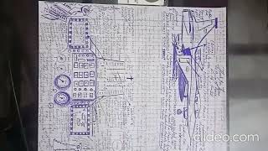
Preview YouTube video Lakshya Title Track - 8K/4K Music Video | Hrithik Roshan | Preity Zinta | Shankar Ehsaan Loy


HTTPS://ELIYASYEDALIABBASP.WIXSITE.COM/LOVE-SERVE-PROTECT
HTTPS://ISTHEONLYWAYJESUSC.WIXSITE.COM/INDIAN
HTTPS://ISTHEONLYWAYJESUSC.WIXSITE.COM/CHRISTIAN
HTTPS://ISTHEONLYWAYJESUSC.WIXSITE.COM/CAPTAIN-PAUL-ELIYA
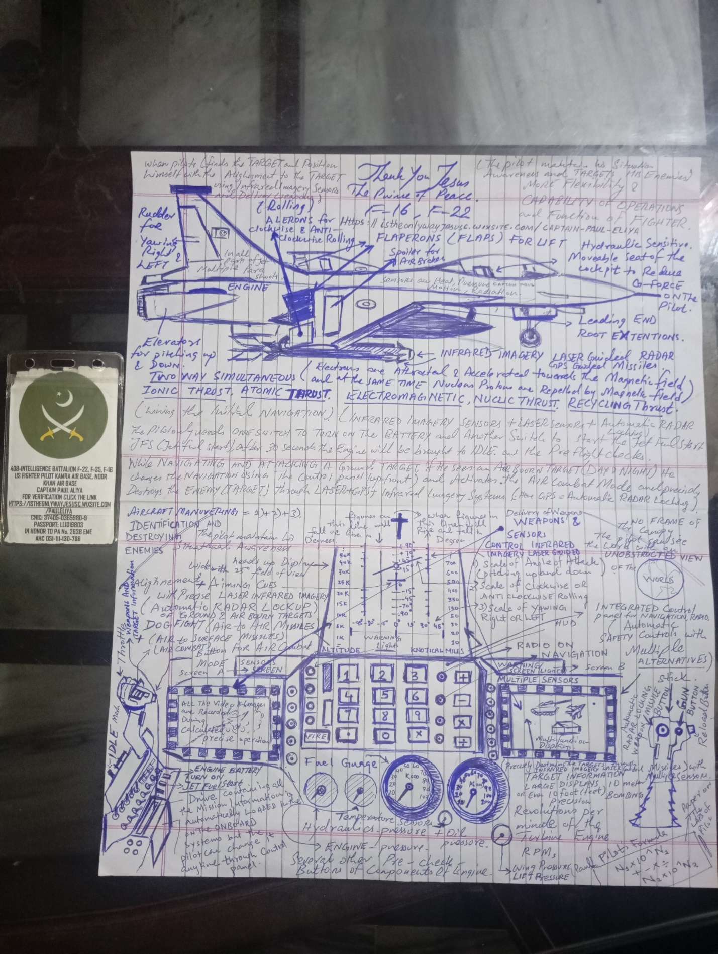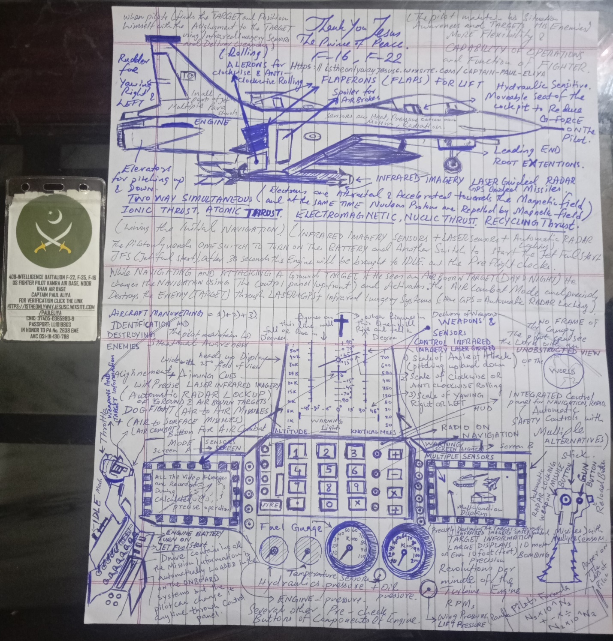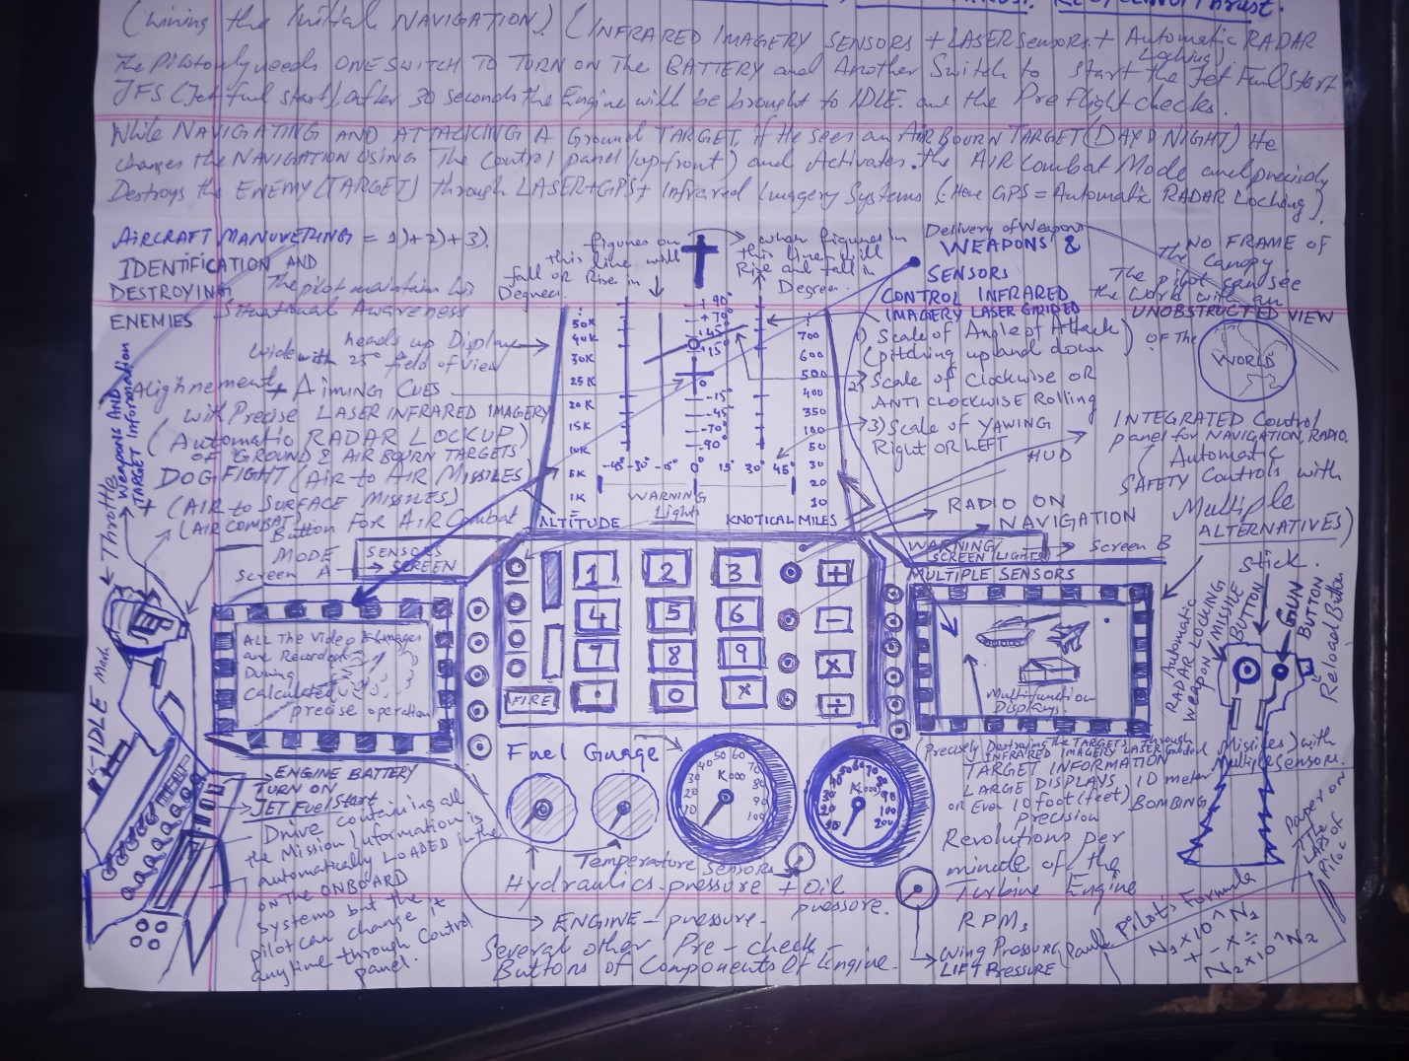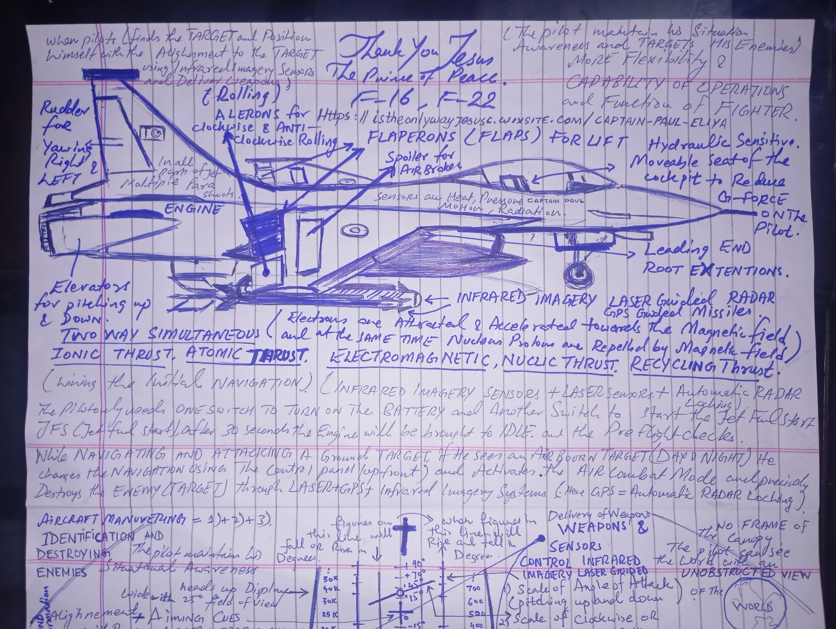

HTTPS://ELIYASYEDALIABBASP.WIXSITE.COM/LOVE-SERVE-PROTECT
HTTPS://ISTHEONLYWAYJESUSC.WIXSITE.COM/INDIAN
HTTPS://ISTHEONLYWAYJESUSC.WIXSITE.COM/CHRISTIAN
HTTPS://ISTHEONLYWAYJESUSC.WIXSITE.COM/CAPTAIN-PAUL-ELIYA

This website was built on Wix. Create yours today.Get Started



408 INTELLIGENCE BATTALION PAKISTAN ARMY OFFICER 408-INTELLIGENCE BATTALION F-22, F-35, F-16 US FIGHTER PILOT KAMRA AIR BASE, NOOR
KHAN AIR BASE CAPTAIN PAUL ALIYAFOR VERIFICATION CLICK THE LINK HTTPS://ISTHEONLYWAYJESUSC.WIXSITE.COM/PAULELIYA IN HONOR TO PA No. 2638 EME BRIG SYED AHMED PIONEER FOUNDER OF NISHAN JEEP SITARA-E-KHIDMAT AHC 051-111-130-786 HTTPS://ISTHEONLYWAYJESUSC.WIXSITE.COM/PAULELIYA HTTPS://ISTHEONLYWAYJESUSC.WIXSITE.COM/TOPGUN HTTPS://ISTHEONLYWAYJESUSC.WIXSITE.COM/TOP-GUN HTTPS://ISTHEONLYWAYJESUSC.WIXSITE.COM/CAPTAIN-PAUL-ELIYA
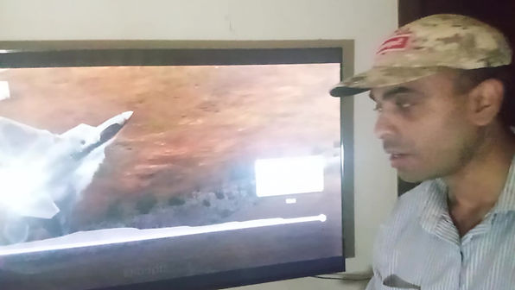
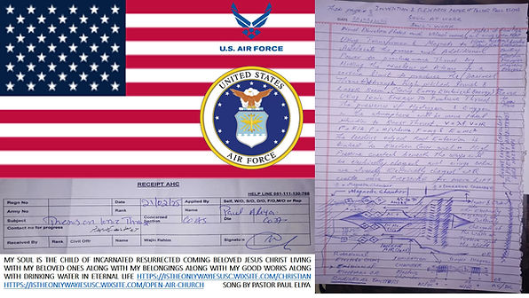
DOWNLOAD
OUR PERSECUTION STORY pdf
OUR PERSECUTION STORY docx
MY DREAM OUR LIFE. docx
MY GOOD WORK.pdf
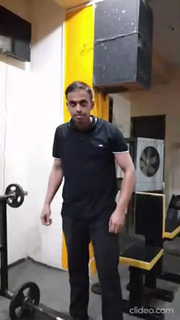
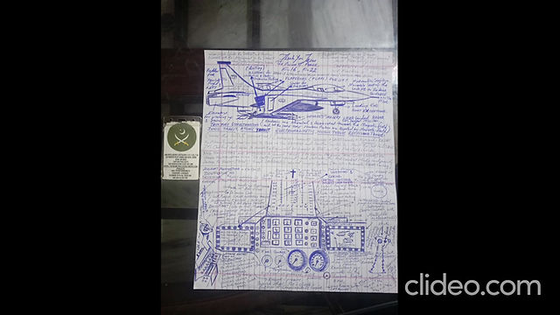
FREE TRAINING
PERFECT FIGHTER PILOT
FREE TRAINING
PERFECT FIGHTER PILOT





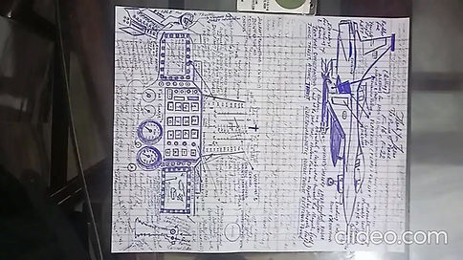
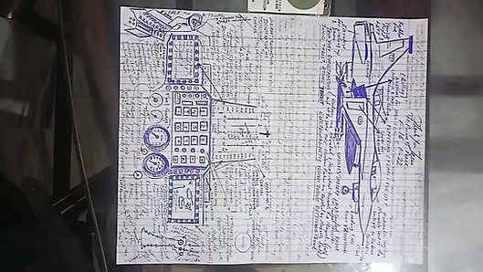

HTTPS://ELIYASYEDALIABBASP.WIXSITE.COM/LOVE-SERVE-PROTECT
HTTPS://ISTHEONLYWAYJESUSC.WIXSITE.COM/INDIAN
HTTPS://ISTHEONLYWAYJESUSC.WIXSITE.COM/CHRISTIAN
HTTPS://ISTHEONLYWAYJESUSC.WIXSITE.COM/CAPTAIN-PAUL-ELIYA

This website was built on Wix. Create yours today.Get Started


408 INTELLIGENCE BATTALION PAKISTAN ARMY OFFICER 408-INTELLIGENCE BATTALION F-22, F-35, F-16 US FIGHTER PILOT KAMRA AIR BASE, NOOR
KHAN AIR BASE CAPTAIN PAUL ALIYA FOR VERIFICATION CLICK THE LINK HTTPS://ISTHEONLYWAYJESUSC.WIXSITE.COM/PAULELIYA IN HONOR TO PA No. 2638 EME BRIG SYED AHMED PIONEER FOUNDER OF NISHAN JEEP SITARA-E-KHIDMAT AHC 051-111-130-786 HTTPS://ISTHEONLYWAYJESUSC.WIXSITE.COM/PAULELIYA HTTPS://ISTHEONLYWAYJESUSC.WIXSITE.COM/TOPGUN HTTPS://ISTHEONLYWAYJESUSC.WIXSITE.COM/TOP-GUN HTTPS://ISTHEONLYWAYJESUSC.WIXSITE.COM/CAPTAIN-PAUL-ELIYA
HTTPS://ELIYASYEDALIABBASP.WIXSITE.COM/LOVE-SERVE-PROTECT
HTTPS://ISTHEONLYWAYJESUSC.WIXSITE.COM/INDIAN
HTTPS://ISTHEONLYWAYJESUSC.WIXSITE.COM/CHRISTIAN
HTTPS://ISTHEONLYWAYJESUSC.WIXSITE.COM/CAPTAIN-PAUL-ELIYA
HTTPS://ISTHEONLYWAYJESUSC.WIXSITE.COM/INDIAN-ORIGIN
OUR PERSECUTION STORY pdf
OUR PERSECUTION STORY docx
MY DREAM OUR LIFE. docx
MY GOOD WORK.pdf
DOWNLOAD
FREE TRAINING
PERFECT FIGHTER PILOT
FREE TRAINING
PERFECT FIGHTER PILOT

